**Science Inquiry and Transport across the Membrane Topic Test 2016**

Name: _______________________________________ score / 65

*Place a cross on the answer you think is most correct. Only choose one letter for each question.*

Multiple Choice Answer Sheet

1. A B C D 11. A B C D

2. A B C D 12. A B C D

3. A B C D 13. A B C D

4. A B C D 14. A B C D

5. A B C D 15. A B C D

6. A B C D 16. A B C D

7. A B C D 17. A B C D

8. A B C D

9. A B C D

10. A B C D

1. Osmosis is a special type of diffusion that deals with the movement of:
2. solutes from an area of high water molecule concentration to an area of low water molecule concentration.
3. water from an area of high water molecule concentration to an area of low water molecule concentration through a semipermeable membrane.
4. solutes from an area of diffusion to an area of low osmotic pressure.
5. solutes from an area of high water molecule concentration to an area of low water molecule concentration through a semipermeable membrane.

[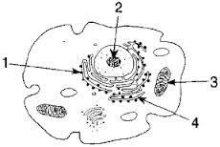](http://www.google.com.au/imgres?um=1&hl=en&biw=1920&bih=931&tbm=isch&tbnid=U89ZmWMusBTYbM:&imgrefurl=http://www.edhsgreensea.net/Biology/taters/cell_parts_quiz_mc.htm&docid=TBrWfSSVlWYqlM&imgurl=http://www.edhsgreensea.net/Biology/taters/taters_images/cell_pic.gif&w=288&h=193&ei=dlE9Ub6OCMjIkQWGxYGYDg&zoom=1&ved=1t:3588,r:78,s:0,i:319&iact=rc&dur=15069&page=3&tbnh=154&tbnw=230&start=76&ndsp=42&tx=101&ty=60)

**The following three questions refer to the diagram to the right**

2. Which of the following contains the correct name and function for **1**

a) Ribosomes are responsible for the production of proteins

b) The smooth endoplasmic reticulum transports substances within the cell and provides a surface for chemical reactions

c) The cytoskeleton consists of microtubules which give the cells its shape and assist with movement of materials

d) Golgi bodies are responsible for the modification of proteins

3. Which of the following contains the correct name and function for **4**

a) The cytoskeleton connects the cell membrane transports substances within the cell and provides a surface for chemical reactions

b) The endoplasmic reticulum transports substances within the cell and provides a surface for chemical reactions

c) The cytoskeleton consists of microtubules which give the cells its shape and assist with movement of materials

d) The endoplasmic reticulum consists of microtubules which give the cells its shape and assist with movement of materials

4. The cells of skeletal muscles contain many mitochondria. This is most likely:

a) To supply the active muscle cells with protein.

b) To supply the active muscles with processed lipids needed for muscle contraction.

c) To supply the active muscle cells with energy.

d) To supply the resting muscle cell with new proteins during growth and repair.

5. Pinocytosis is the:

a) movement of solids through a semi permeable membrane.

b) the engulfing of liquids by the cell membrane.

c) the movement of liquids out of the cell.

d) the production of pinoplasts to remove wastes from a cell.

6. Choose the **incorrect** statement.

a) Active transport can move solutes from an area of high solvent concentration to an area of low solvent concentration

b) Active transport requires energy

c) Active transport can move solutes from an area of high solute concentration to an area of low solute concentration

d) Active transport can move substances against the concentration gradient

7. Which of the following statement is true?

a) Water can travel through the hydrophobic phosphate heads of a phospholipid bilayer.

b) Water can travel through the hydrophobic lipid tail of a phospholipid bilayer.

c) Water cannot travel through the hydrophobic phosphate heads of a phospholipid bilayer.

d) Water cannot travel through the hydrophobic tails of a phospholipid bilayer.

Use the diagram below to answer questions 8 and 9.

[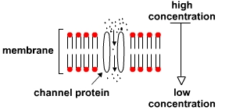](http://www.google.com.au/url?sa=i&rct=j&q=&esrc=s&source=imgres&cd=&cad=rja&uact=8&ved=0ahUKEwjj-NrW7NDKAhVCLmMKHUY6Dq8QjRwICTAA&url=http://study.com/academy/lesson/facilitated-diffusion-definition-process-examples.html&psig=AFQjCNHKgla1cVTIrAM4Kn38wp8aIuNBQQ&ust=1454219700686418)

8. The diagram above shows:

a) Facilitated diffusion

b) Active transport

c) Pinocytosis

c) Movement of steroids

9. In the diagram above, which of the following could move through the channel protein?

a) Water by active transport.

b) Water by osmosis.

c) Steroids by active transport.

d) Large proteins by diffusion.

10. A group of cells that are structurally alike and which perform a particular function are called:

a) A system.

b) A tissue.

c) An organ.

d) A nerve.

11. If a mixture of proteins and glucose is placed in a bag immersed in water, the glucose will diffuse through the bag but the protein will not. This is because the bag is:

* 1. a living membrane
  2. selectively permeable
  3. permeable only to molecules of inorganic origins
  4. impermeable to all except large organic molecules

12. The organelles in the cell which are responsible respectively for protein synthesis, energy production and secretion are:

a) ribosomes, Golgi bodies, endoplasmic reticulum

1. Golgi bodies, ribosomes, mitochondria
2. Ribosomes, mitochondria, Golgi bodies
3. Mitochondria, ribosomes, endoplasmic reticulum

13. The type of tissue lining the digestive tract is:

* 1. epithelial tissue
  2. connective tissue
  3. muscular tissue
  4. contractile tissue

Use the table below to answer questions 14 and 15.

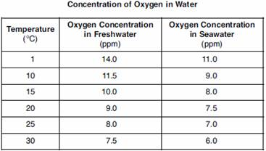

14. The most suitable graph for the data above would be:

a) a pie chart/graph.

b) a bar graph.

c) a line graph.

d) a Semi-log graph.

15. The dependent variable for the experiment that the graph came from could be:

a) Oxygen concentration.

b) Water temperature.

c) Salt water or Freshwater.

d) Temperature and Salinity.

Use the diagram below to answer question 16.

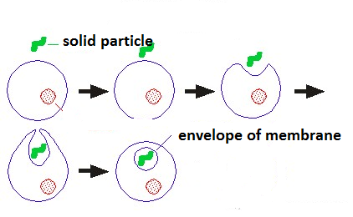

16. This diagram shows an example of:

a) exocytosis phagocytosis.

b) endocytosis phagocytosis

c) exocytosis pinocytosis.

d) endocytosis pinocytosis.

Use this diagram to answer question 17.

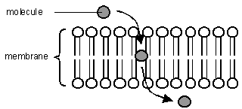

17. The molecule being transferred in the diagram is likely to be:

a) a steroid or alcohol.

b) a steroid or water molecule.

c) a large protein molecule or a steroid.

d) a large protein molecule or a water molecule.

**QUESTION 1** (Total 8 marks)

The diagram below refers to Question 1.

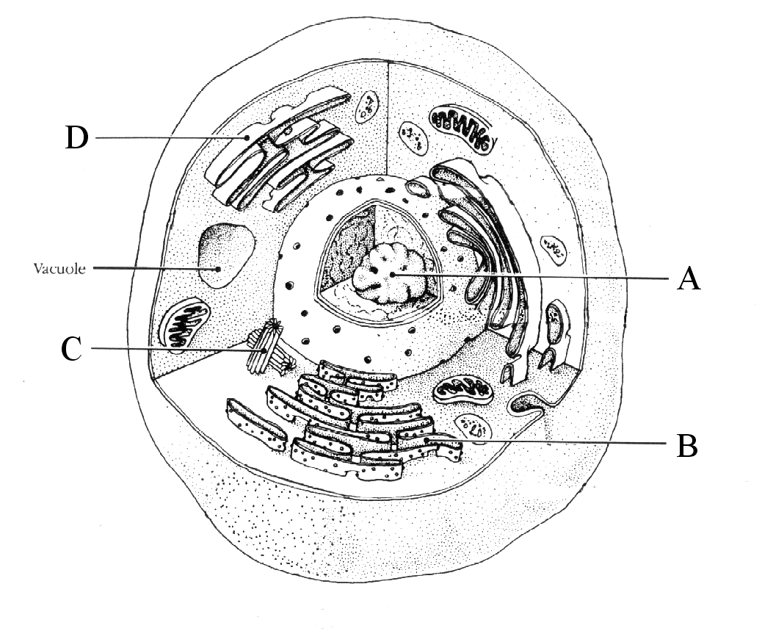

|  |  |  |
| --- | --- | --- |
| **Structure** | **Name** | **Function** |
| **A.** |  |  |
| **B.** |  |  |
| **C.** |  |  |
| **D.** |  |  |

**2.** An investigator was examining possible factors which might contribute to traffic accidents. One of the factors examined was the effect of sleep deprivation (lack of sleep) on people’s reaction times.

The table below shows the average reaction times of a group of people after they had been awake for a certain number of hours

|  |  |
| --- | --- |
| **Hours since last sleep** | **Average reaction time (ms)** |
| 12 | 250 |
| 16 | 265 |
| 18 | 312 |
| 20 | 364 |
| 22 | 422 |

a) Graph this data on the grid below. (5 marks)



b) Using your graph, predict the reaction time of a person who had been awake for:

(i) 14 hours _______________________________________

(ii) 24 hours _______________________________________

(2 marks)

d) Which of your predictions in the question above are you more confident about? Explain why.

_____________________________________________________________________________________________

_____________________________________________________________________________________________

_____________________________________________________________________________________________

(3 marks)

**3.** A paediatrician (doctor for children) was trialling a new vitamin drink which he hoped would increase growth height in children who were small for their age. He trialled eight 7 year old children who were a variety of heights. He gave each a drink each day for 6 months. Children numbered 1 - 4 were given the vitamin drink, children numbered 5 – 8 were given a placebo.

|  |  |  |  |
| --- | --- | --- | --- |
| Group | Child number | Height before (cm) | Height after (cm) |
| Given Vitamin Drink | 1  2  3  4 | 100  105  106  96 | 100  106  108  100 |
| Given Placebo | 5  6  7  8 | 105  102  95  107 | 106  103  100  109 |

1. What was the independent variable for this investigation?

____________________________________________________________________________________________________________________________________________________________________________________________________________________________________________________________________________________________________________________________________________________________________

(1 mark)

1. What was the dependent variable for this investigation?

____________________________________________________________________________________________________________________________________________________________________________________________________________________________________________________________________________________________________________________________________________________________________

(1 mark)

1. Which group of children were the control group?

__________________________________________________________________________________________________________________________________________________________________________________

(1 mark)

1. What should be done with the data before it is shown on a graph?

___________________________________________________________________________________________________________________________________________________________________________________________________________________________________________________________________________

(1 mark)

1. How can the accuracy be further increased and the error further decreased?

____________________________________________________________________________________________________________________________________________________________________________________________________________________________________________________________________________________________________________________________________________________________________

(1 mark)

1. What is the most suitable graph for this data? Give a reason for your choice.

____________________________________________________________________________________________________________________________________________________________________________________________________________________________________________________________________________________________________________________________________________________________________

(3 marks)

1. Suggest a possible starting hypothesis for this investigation.

_____________________________________________________________________________________________________________________________________________________________________________________________________________________________________________________________________________________________________________________________________________________________________________________________________________________________________________________________

(2 marks)

4. Explain how active facilitated transfer occurs through the cell membrane. Accompany your answer with a suitable labelled diagram.

(6 marks)

____________________________________________________________________________________________________________________________________________________________________________________________________________________________________________________________________________________________________________________________________________________________________________________________________________________________________________________________________________________________________________

5. Complete this table.

|  |  |
| --- | --- |
| Type of Membrane Protein | Function |
| Channel |  |
| Carrier |  |
| Receptor |  |
| Recognition |  |

(8 marks)

6. Use the diagram below to answer the questions that follow.

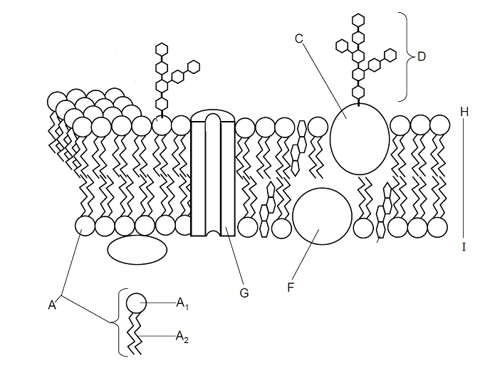

1. In the diagram above structures C, G and F can be described as which type of molecule?

________________________________________________________________

(1 mark)

1. For structures A1 and A2 in the diagram above, complete this table.

|  |  |  |
| --- | --- | --- |
| Letter | Name of structure | Response to water? |
| A1 |  |  |
| A2 |  |  |

(4 marks)

1. The diagram above shows a model to explain the structure of the plasma (cell) membrane. What is this model called?

__________________________________________________________________________________________________________________________________________

(1 mark)